**Tutorial No: 04 Gantt chart, Critical Path Analysis.**

**GANTT CHART:**

**Generalized Activity Normalization Time Table (GANTT) chart** is type of chart in which series of horizontal lines are present that show the amount of work done or production completed in given period of time in relation to amount planned for those projects. It is horizontal bar chart developed by Henry L. Gantt (American engineer and social scientist) in 1917 as production control tool. It is simply used for graphical representation of schedule that helps to plan in an efficient way, coordinate, and track some particular tasks in project.

The purpose of Gantt chart is to emphasize scope of individual tasks. Hence set of tasks is given as input to Gantt chart. Gantt chart is also known as timeline chart. It can be developed for entire project or it can be developed for individual functions. In most of projects, after generation of timeline chart, project tables are prepared. In project tables, all tasks are listed in proper manner along with start date and end date and information related to it.

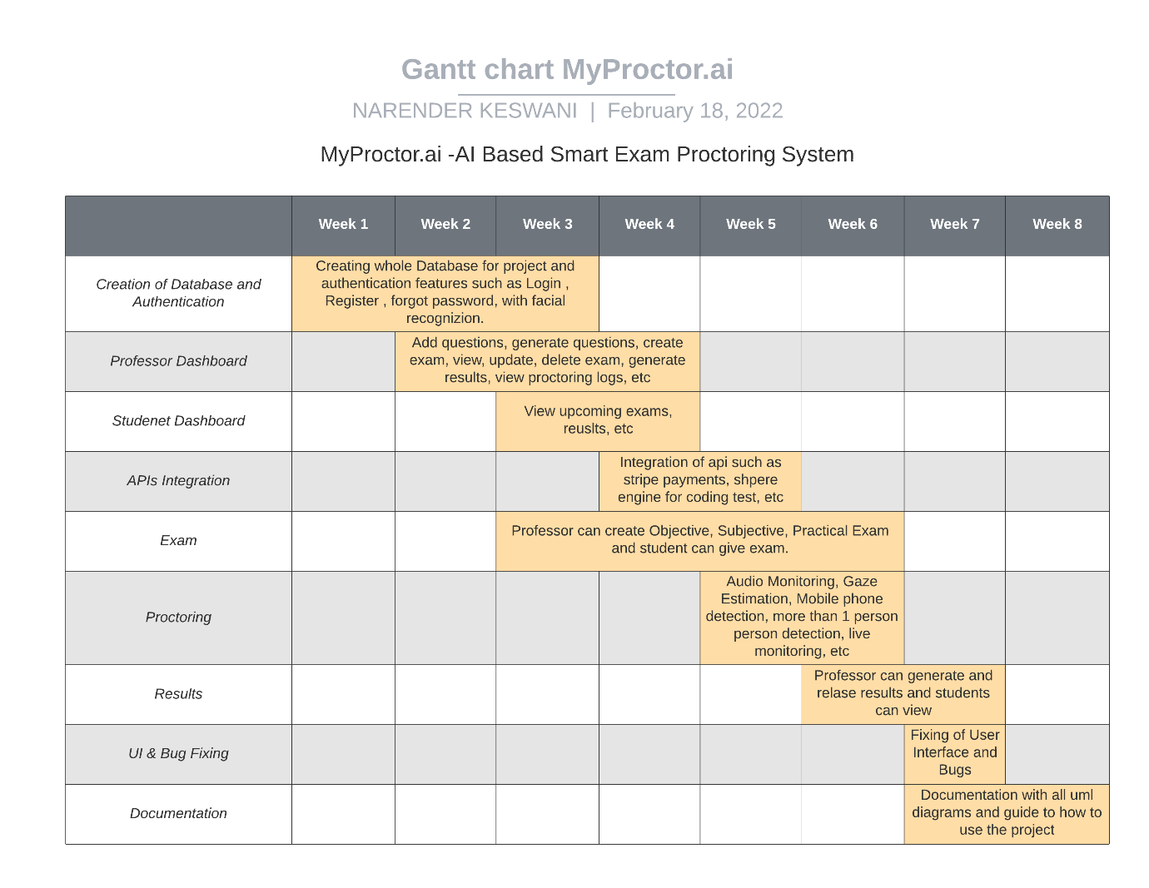

**CRITICAL PATH ANALYSIS:**

Critical Path Method (CPM) is a method used in project planning, generally for project scheduling for the on-time completion of the project. It actually helps in the determination of the earliest time by which the whole project can be completed. There are two main concepts in this method namely critical task and critical path. **Critical task** is the task/activity which can’t be delayed otherwise the completion of the whole project will be delayed. It must be completed on-time before starting the other dependent tasks.

**Critical path** is a sequence of critical tasks/activities and is the largest path in the project network. It gives us the minimum time which is required to complete the whole project. The activities in the critical path are known as critical activities and if these activities are delayed then the completion of the whole project is also delayed.

**Major steps of the Critical Path Method:**

1. Identifying the activities
2. Construct the project network
3. Perform time estimation using forward and backward pass
4. Identify the critical path

|  |  |  |  |  |
| --- | --- | --- | --- | --- |
| **Sr. No.** | **Builds** | **From** | **To** | **Time** |
| **1** | **Build 1** | **09/02/2021** | **20/02/2021** | **11 Days** |
| **2** | **Build 2** | **21/02/2021** | **05/03/2021** | **13 Days** |
| **3** | **Build 3** | **05/03/2021** | **21/03/2021** | **16 Days** |
| **4** | **Build 4** | **22/03/2021** | **01/04/2021** | **11 Days** |
| **4** | **Build 5** | **02/04/2021** | **15/04/2021** | **14 Days** |

